Kids

Weather words

Weather experiments

Weather facts

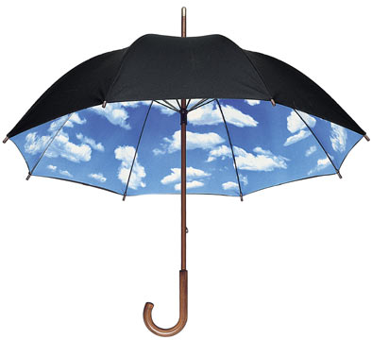

**Weather words – what do they mean??**

[**Altitude**](http://www.metoffice.gov.uk/education/kids/weather_words_altitude.html)

Altitude is another word for height. When you are flying in an aeroplane, you are at a higher altitude than when you are on the ground. If you climb a mountain, you are at a higher altitude at the top than at the bottom. Altitude can be measured in metres or in feet, and starts from sea level — which is the surface of the ocean. If you are at sea level, you are at zero altitude.

**Atmosphere**

The atmosphere is all around us. It is the air we breathe. It is a layer of air which covers the whole of Earth. It is several miles high, and beyond the atmosphere is space.

**Climate**

Climate is the word we use for weather over a long period of time. The desert has a dry climate, because there is very little rain. The UK has a 'temperate climate' which means winters are, overall, mild and summers, generally, don't get too hot.

**Clouds**

Clouds are made of lots tiny drops of water that float in the air. Clouds can be white, grey or dark grey. The darker a cloud, the more water it is carrying, and the more likely it is to drop that water as rain, snow or hail. Clouds float because the water in them is warmer than the air around them. Clouds can be different shapes, but have three main types. Cirrus clouds are white, thin and wispy. Cumulus clouds are white and fluffy like cotton wool. Stratus clouds are grey and cover the whole sky.

**Condensation**

You might have seen the effects of condensation before, such as when a car window steams up. This is because tiny, invisible drops of water float around in the air, this is called vapour. When vapour in the air gets colder it changes from being a vapour into a liquid which we can see. It happens on car windows because they are often colder on the outside, and so vapour turns into water as it touches the glass. Another way to see condensation in action is to take a bottle of water from a fridge and leave it out in a room for a few minutes — a thin layer of water will form on it. This is because the vapour in the air cools as it touches the cold bottle, causing condensation.

**Drought**

Droughts happen when it does not rain for a long time. This makes the land dry. Lakes, ponds and rivers run low. People have to use less water when there is a drought to make sure there is enough to drink. Hot countries often suffer droughts.

**Evaporation**

Puddles left after it has rained slowly disappear. This is because of evaporation, which happens with all water, even the oceans. Evaporation happens when water is heated up by the sun. The water turns into vapour — tiny droplets of water which float on the air. As a whole puddle is slowly turned into vapour, eventually it dries up. Evaporation is the opposite of condensation.

**Humidity**

Humidity is how damp the air feels. There are always tiny droplets of water called water vapour floating in the air. Humidity is a measure of the amount of water vapour in the air. Weather forecasters need to know the humidity because it helps them predict rain and fog.

**Hurricane**

Hurricanes are tropical storms with very strong winds and heavy rain. They usually affect warmer parts of the world, such as the Caribbean and the coast of North America where the sea temperatures are higher than 26 °C. They can cause lots of damage as they pass over land, with thunderstorms and tornadoes at times. Tropical storms are also known as cyclones or typhoons in other parts of the world. We don't get hurricanes in the UK, but we do sometimes get very strong winds which can be called hurricane force winds (more than 64 mph).

**Lightning**

Lightning is a large flash of electricity from the sky to the ground. It happens when there is a thunderstorm. Lightning is very dangerous and as much as six times hotter than the sun.

**Meteorology**

The study of the atmosphere and all its elements, including weather and how to forecast it.

**Monsoon**

A seasonal wind, found especially in Asia that reverses direction between summer and winter and often brings heavy rains.

**Ozone**

About 19-30 kilometres above the Earth is a layer of gas called ozone, which is a form of oxygen. Ozone reflects harmful rays from sunlight back to space.

**Rain**

Rain is drops of water that fall to the Earth from clouds in the sky. Rain is important because it gives us fresh water for plants to grow and animals to drink. The amount of rain is measured using a rain gauge.

**Temperature**

Temperature is a measure of how hot or cold it is. Thermometers are used to measure the temperature.

**Thunder**

Thunder is the sound that follows a flash of lightning.

**Transpiration**

Plants get water from the ground to help them grow. Some of this water comes out of their leaves and goes out into the air. This is transpiration. It is like plants breathing.

**Water Cycle**

The water cycle is a way in which water moves around the world. Without it, nothing would grow and humans would not be able to live. It starts in the ocean, where the heat of the Sun turns sea water into vapour, tiny droplets of water which float in the air - this process is called evaporation. Water vapour rises into the sky to make clouds. The wind blows the clouds over land and they drop their water as rain, sleet or snow. This falls on the land as water, which allows plants to grow and gives us drinking water. Much of the water then flows into lakes and rivers, and is carried back to the sea. Then the process begins again.

**Weather**

Weather is all around us. If you look outside, you will see it is sunny or cloudy. It may be dry or wet. It may be calm or the wind may be blowing. It may be cold or warm. All these things are the weather. What is the weather doing outside your window?

**Weather Forecast**

You can see weather forecasts on the television and hear them on the radio. You can look at them on the internet or in newspapers. They tell us what the weather is going to be like today, tomorrow, and sometimes even further ahead. Experts make them by using their knowledge of the weather and special equipment to predict what will happen next. We need weather forecasts to help plan our lives. If it is going to be hot and sunny, we can plan to go swimming. If it is going to be very cold, we can wrap up warm. If it is going to rain, we can take an umbrella.

**Weather Satellite**

Satellites are launched into space on a rocket. Once there, they orbit (go around) the Earth collecting information with their advanced equipment. They beam the information back to supercomputers on Earth. Weather satellites take pictures of the Earth from above, helping scientists understand what the weather is doing and what might happen next.

**Weather Station**

A weather station is a place where there is lots of equipment, specially made to record made to record information about the weather. They record how hot or cold it is; how much rain falls; how fast the wind is moving and lots of other things. There are weather stations all over the world, including on some mountain tops. The information is sent to computers so people know what the weather is doing at each station. The information also helps people to understand the weather, and what it might do next.

**Wind**

Wind is air moving around. Some winds can move as fast as a racing car, over 100 miles an hour. Winds can travel around the world. Wind can make you feel cold because you lose heat from your body faster when it is windy. Weather forecasters need to know the speed and direction of the wind. The strength of wind is measured using the Beaufort scale from wind force 0 when there is no wind, to wind force 12 which can damage houses and buildings and is called hurricane force.

**Weather experiments**

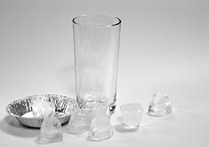**Make a cloud in a glass**

**What you will need:**

* A clear glass or similar see-through container
* Warm water
* Ice
* Metal or foil dish

**What to do:**

1. Place the ice into the metal dish.
2. Pour a small amount of warm water into the bottom of the glass.
3. Wait until the dish is really cold. Then place it on top of the glass.
4. Watch the inside carefully. You should see a 'cloud' form near the top of the glass.

This is the way clouds form in the real world. Warm, moist air like that in your glass, is cooled (your ice). When it is cooled it condenses into tiny water droplets, which appear as clouds.

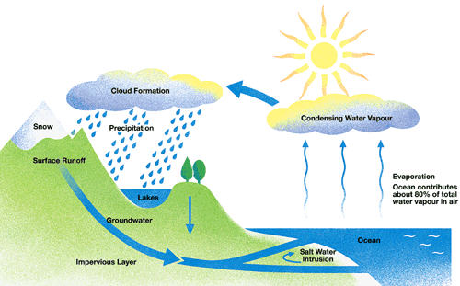

**Water cycle**

**What you will need:**

* A large b owl
* A small yogurt pot or plastic cup
* Clingfilm
* Water
* Small weight or a few coins
* Sunny window sill

**What to do:**

1. Take the large bowl and fill it with several centimetres of water.
2. Place your small pot in the centre of the bowl of water, making sure not to get any water inside it.
3. Cover the large bowl with clingfilm and fasten this down securely to the side of the bowl.
4. Put a weight on top of the clingfilm, over the centre of the small pot to push the clingfilm down into it slightly.
5. Place your experiment on a warm sunny window sill and leave for a few days.

You should find that the heat of the sun evaporates the water, which rises, condenses on the cool plastic, and falls into the small container. This is a small version of what happens in the real water cycle.

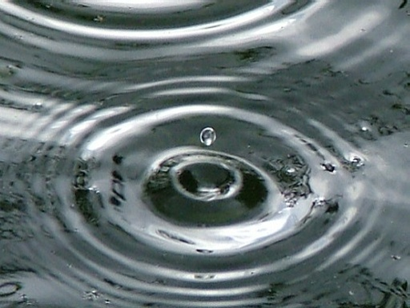**Make rain**

**What you will need**

* A glass mayonnaise jar
* A plate
* hot water
* ice cubes

**What to do**

* 1. Pour about two inches of very hot water into the glass jar.
  2. Cover the jar with the plate and wait a few minutes before you start the next step
  3. Put the ice cubes on the plate.

What happens? The cold plate causes the moisture in the warm air, which is inside the jar to condense and form water droplets. This is the same thing that happens in the atmosphere. Warm, moist air rises and meets colder air high in the atmosphere. The water vapor condenses and forms precipitation that falls to the ground.

[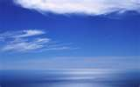](http://rds.yahoo.com/_ylt=A0PDoX5RmT9ORWAAg2ajzbkF/SIG=12f7m3nj1/EXP=1312819665/**http%3a/www.hdwallpapers.in/wallpapers/blue_sky-1440x900.jpg)**Blue sky experiement**

**What you need**

* flashlight /torch
* large water bottle
* milk
* water

**What to do**

1. Fill the bottle three-fourths full of water and prop up the flashlight, so it will shine through the bottle from the side.
2. Add a teaspoon of milk to the water.
3. Put the cap on the bottle and shake to mix up the water and milk.
4. What do you see? Keep adding milk until you start to see a blue light that is scattered to your eyes from the mixture.
5. Once you see the blue light, add more milk to the mixture until you see more of an orange or red light.

## Just like in the atmosphere, the mixture scatters more of the blue wavelength than any other color.

## The sky is blue because molecules in the air scatter blue light from the sun more than they scatter red light.

|  |
| --- |
| http://upload.wikimedia.org/wikipedia/commons/6/63/Dispersion_prism.jpg When we look towards the sun at sunset, we see red and orange colours because the blue light has been scattered out and away from the line of sight.  The white light from the sun is a mixture of all colours of the rainbow. This was demonstrated by Isaac Newton, who used a prism to separate the different colours and so form a spectrum. The colours of light are distinguished by their different wavelengths. The visible part of the spectrum ranges from red light with a wavelength of about 720 nm, to violet with a wavelength of about 380 nm, with orange, yellow, green, blue and indigo between. The three different types of colour receptors in the retina of the human eye respond most strongly to red, green and blue wavelengths, giving us our colour vision.  **Tyndall Effect**  The first steps towards correctly explaining the colour of the sky were taken by John Tyndall in 1859. He discovered that when light passes through a clear fluid holding small particles in suspension, the shorter blue wavelengths are scattered more strongly than the red. This can be demonstrated by shining a beam of white light through a tank of water with a little milk or soap mixed in. From the side, the beam can be seen by the blue light it scatters; but the light seen directly from the end is reddened after it has passed through the tank. The scattered light can also be shown to be polarised using a filter of polarised light, just as the sky appears a deeper blue through polaroid sun glasses.  This is most correctly called the Tyndall effect, but it is more commonly known to physicists as Rayleigh scattering--after Lord Rayleigh, who studied it in more detail a few years later. He showed that the amount of light scattered is inversely proportional to the fourth power of wavelength for sufficiently small particles. It follows that blue light is scattered more than red light by a factor of (700/400)4 ~= 10. Dust or Molecules?  Tyndall and Rayleigh thought that the blue colour of the sky must be due to small particles of dust and droplets of water vapour in the atmosphere. Even today, people sometimes incorrectly say that this is the case. Later scientists realised that if this were true, there would be more variation of sky colour with humidity or haze conditions than was actually observed, so they supposed correctly that the molecules of oxygen and nitrogen in the air are sufficient to account for the scattering. The case was finally settled by Einstein in 1911, who calculated the detailed formula for the scattering of light from molecules; and this was found to be in agreement with experiment. |

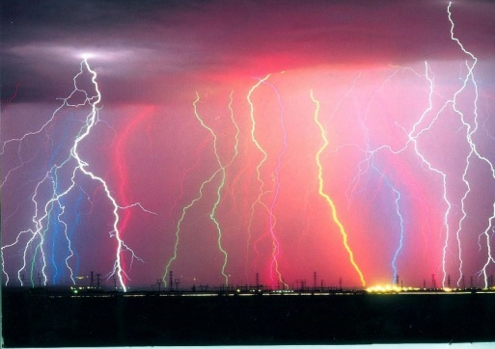**Interesting Weather Facts**

* A bolt of lightning can travel at up to 136,000mph and reach temperatures of 30,000 °Celsius — hotter than the surface of the Sun!
* A hailstone almost the size of a bowling ball fell in Nebraska, in the USA, on 22 June 2003. Measuring 17.8cm in diameter, it is the largest hailstone ever recorded.
* Ice in the Antarctic is more than 3 km thick in places.

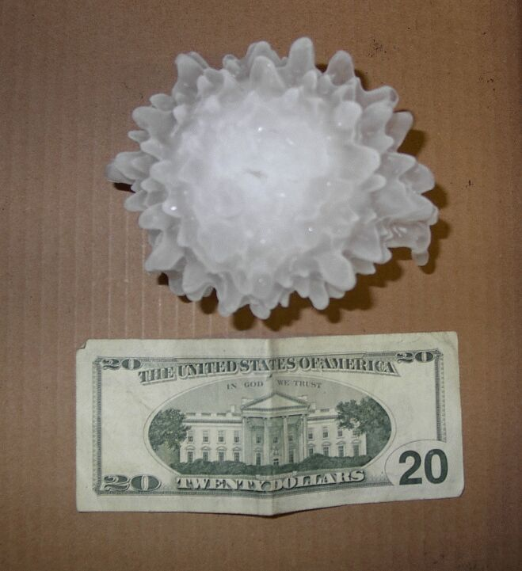

* There are some special aeroplanes which have been designed to fly directly into hurricanes. These planes are packed with equipment to gather information on the hurricane. Weather forecasters then use the information to predict where the storm will go, giving people early warnings of the danger
* A tornado, which lasted for more than three hours and was three miles wide, is the deadliest in history. The giant storm hit three southern states in the USA on 18 March, 1925 and killed 747 people.
* 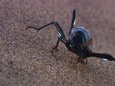The windiest place on Earth is Port Martin, in Antarctica. Here winds average more than 40mph on at least 100 days every year. The place with the least wind is also in Antarctica, at a site called Dome A. Here the wind hardly blows at all. This shows how Antarctica is a place of extremes.
* The Sahara Desert gets very little rain. For three years from 1973 to 1976, almost no rain fell at all.
* 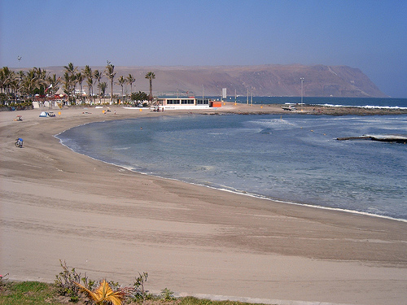There is water available in the desert in the form of dew. This occurs when water vapour in the air condenses at on sand that has been cooled during the night. The darkling beetle in the Namib Desert stands still at dawn to collect dew on its own body to drink.
* 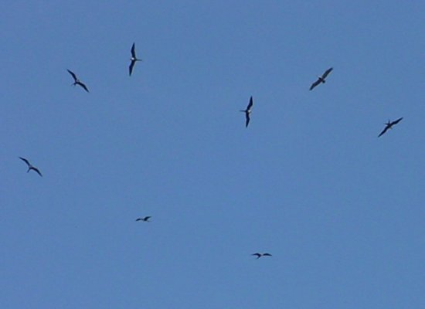One of the driest places on earth is Arica in Chile (South America), where less than 1mm of rain falls every year. A coffee cup would take around 100 years to fill!
* Every minute of the day, around 900 million tonnes of rain falls on the Earth
* ‘Thermals’ are convection currents of hot air rising into the atmosphere. Thermals can be caused by an area of the ground that is dark and has therefore absorbed more of the sun’s energy (e.g. a forest). Birds and pilots recognize places where thermals are likely to be found and use these to ascend with minimum effort.